Project Title:
Smart Helmet Accident Detection and Alert System using IoT
Group Name:
Tech Pioneers
Group Members:
- Muhammad Ali Akram 23-NTU-CS-1062
- Muhammad Shawaiz 23-NTU-CS-1073
- Muhammad Zohaib Saeed 23-NTU-CS-1079
Department:
Computer Science – BSCS – 5th - B
Instructor Name:
Sir Nasir Mehmood
Institution:
National Textile University, FSD
Academic Year:
2024–2025

Problem Statement and Objectives

Problem Statement
Road accidents involving two-wheelers often result in severe injuries or fatalities due to delayed emergency response. In many cases, the rider becomes unconscious and is unable to manually request help or share their location, leading to critical delays in rescue operations.

Objectives
- To detect a bike accident automatically using motion sensors.
- To alert emergency contacts with the rider’s real-time location.
- To allow cancellation of false alerts using a secure PIN-based mechanism.
- To provide cloud-based monitoring and visualization of rider location.
- To design a low-cost, reliable, and practical IoT-based safety system.

System Architecture / Block Diagram (Describe this)

System Architecture Description
The system consists of three main units:
- Helmet Unit
- Mobile Application Unit
- Cloud Dashboard Unit

Architecture Flow
MPU6050 Sensor
↓
ESP32 (NodeMCU)
↓ Bluetooth
MIT App Inventor Mobile App
↓
GPS Location Acquisition
↓
10-second Cancel Timer (PIN-based)
↓
SMS Alert to Emergency Contacts

Parallel:
ESP32 / Mobile → Blynk Cloud → Dashboard

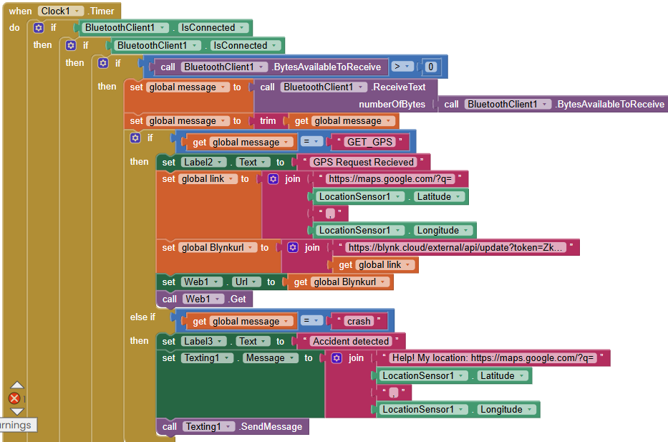

Hardware and Software Description

Hardware Components
- NodeMCU ESP32 (38-pin)
- MPU6050 Accelerometer & Gyroscope
- Push Button (manual trigger / cancel backup)
- Buzzer
- LEDs (Status indicators)
- Resistors (1K, 10K, 220Ω)
- Breadboard and jumper wires
- Power supply / battery

Software Components
- Arduino IDE (ESP32 programming)
- MIT App Inventor (Android application)
- Blynk IoT Platform (Cloud dashboard)
- Android OS (Mobile GPS and SMS services)

Methodology and Flowchart

Methodology (Step-by-Step)
- MPU6050 continuously monitors acceleration and angular motion.
- Sudden abnormal motion indicates a possible accident.
- ESP32 sends an alert signal to the mobile phone via Bluetooth.
- MIT App receives the alert and starts a 10-second countdown.
- Rider can cancel the alert by entering a PIN.
- If not cancelled:
  - Mobile GPS retrieves latitude and longitude.
  - SMS containing Google Maps location link is sent automatically.
- Blynk dashboard allows manual sharing of rider’s current location.

Flowchart (Text Description)
Start
↓
Read MPU6050 Data
↓
Accident Detected?
├─ No → Continue Monitoring
└─ Yes
↓
Send Alert to Mobile (Bluetooth)
↓
Start 10s Timer
↓
PIN Entered?
├─ Yes → Cancel Alert
└─ No
↓
Get GPS Location
↓
Send SMS Alert
↓
End

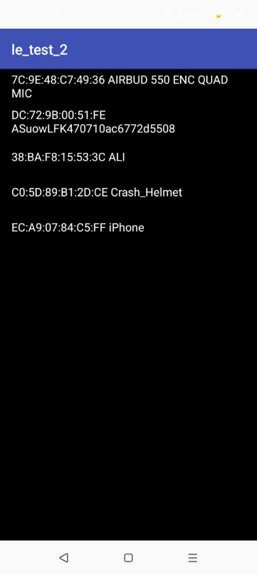
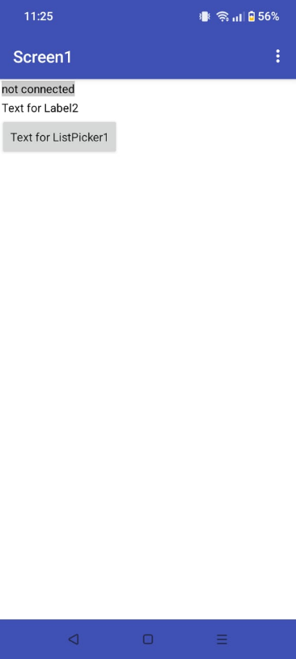
Screenshots of Output and Dashboards
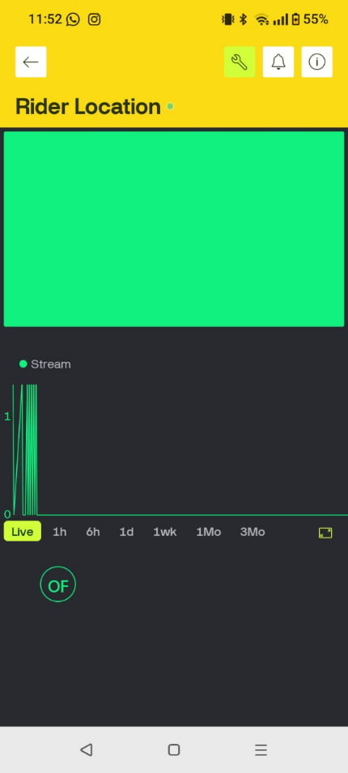
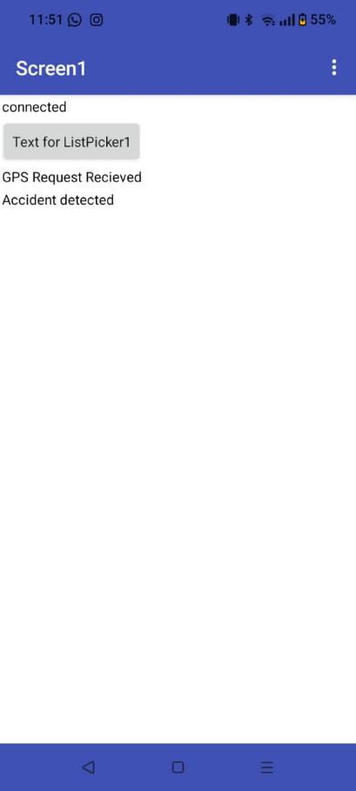
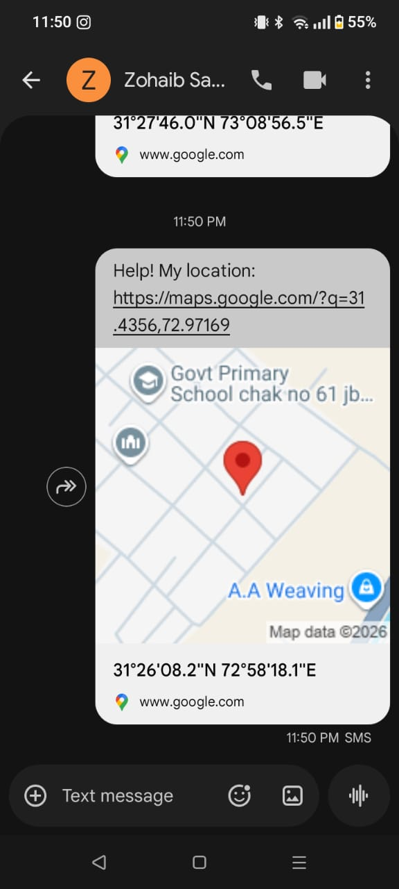

Results
- The system successfully detects crash conditions using MPU6050.
- Alert is transmitted to the mobile device within seconds.
- GPS location is accurately shared via SMS.
- False alerts can be prevented using PIN-based cancellation.
- Blynk dashboard correctly displays rider location data.

Conclusion
The proposed Smart Helmet Accident Detection System effectively improves rider safety by providing automatic accident detection and emergency alerting. By leveraging IoT, mobile sensors, and cloud platforms, the system ensures quick response while remaining cost-effective and practical.

Future Scope
- Integration of GPS module directly into helmet.
- WhatsApp or cloud-based alert system.
- Machine learning-based accident severity analysis.
- Emergency service integration.
- Long-term accident data analytics.

IoT and Technical Compliance

Cloud Platform Used
Blynk Cloud

Cloud Usage Description
- Used for real-time rider location monitoring.
- Provides IoT dashboard for visualization.
- Enables remote access to rider data.

Dashboard Data Validation
Dashboard displays correct and real-time data
Location sharing works on user interaction

